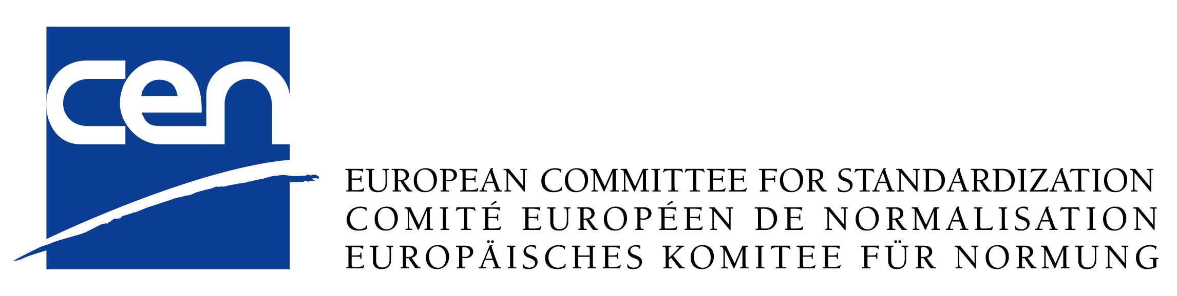
RESULT OF TC APPROVAL ON
DRAFT TECHNICAL REPORT
FprCEN/TR |  |  |  |  |  |  |  |  |  |  |  |  |  | Conclusion :
Originator : | CEN/TC |  |  |  |  |  |  |  |  |  |  | Secretariat :
Work item :
Title :
Submission date : |  |  |  |  |  |  |  |  |  |  |  |  | Deadline :
 |  |  |  |  |  |  |  |  |  | Agreement with
CEN member |  | Date of |  |  |  | Votes |  |  |  | the translation |  |  |  |  |  |  |  | Remarks
country |  | reply |  |  | Acc. | Rej. |  | Abs. |  | of titles
Austria
Belgium
Bulgaria
Croatia
Cyprus
Czech
Republic
Denmark
Estonia
Finland
Former Yugoslav Republic of Macedonia
France
Germany
Greece
Hungary
Iceland
Ireland
Italy
Latvia
Lithuania
Luxembourg
Malta
Netherlands
Norway
Poland
Portugal
Romania
Slovakia
Slovenia
Spain
Sweden
Switzerland
Turkey
United
Kingdom
Total of voting (simple majority)

Result of TC Approval on FprCEN/TR
 |  |  |  | Result |  | Condition fulfilled
Number of members voting affirmatively to be more than that of members voting negatively (simple majority, abstentions excluded)
Conclusion:

